WEEK 6 :Database integration and CRUD opertaions
Creating database
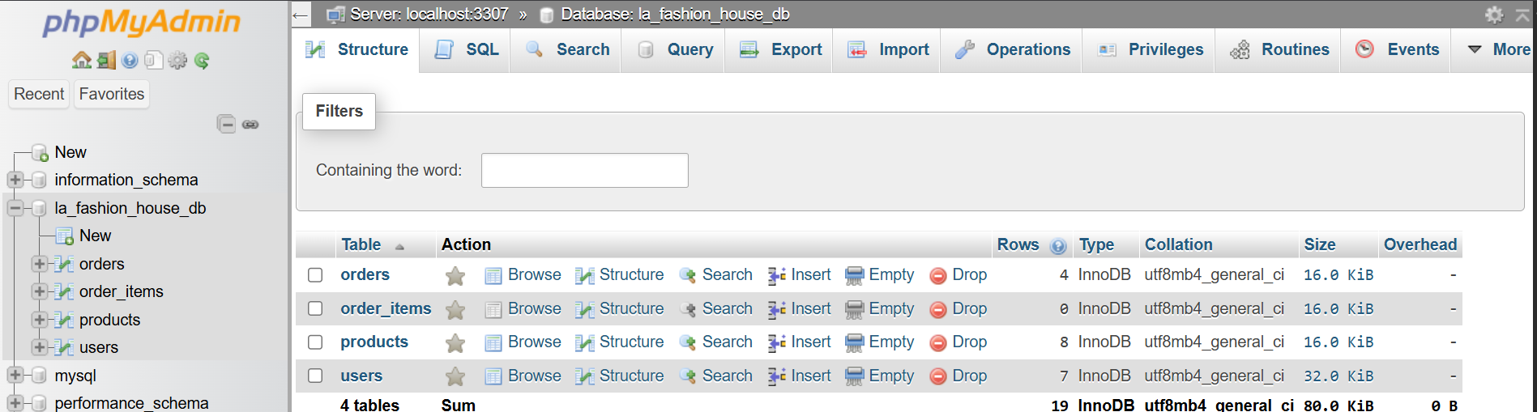
Fig1: Shows the successful creation of a database using phpmyadmin
Connecting PHP to MySQL
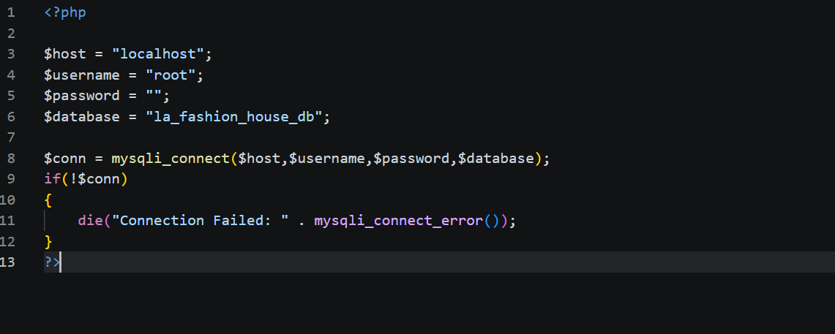
I successfully connected PHP to MySQL. This is to represent how database where data is stored(phpmyadmin) for the specific tables is connected to the system and interaction.

Creation of tables in the database

Fig 2: Shows the sql query to create a table in the database created in fig 1.This shows the specific table entries that will be viewed.
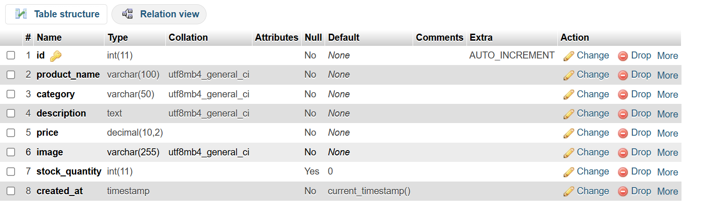
Shows the table created successfully in the database .
CREATE(Adding new product)
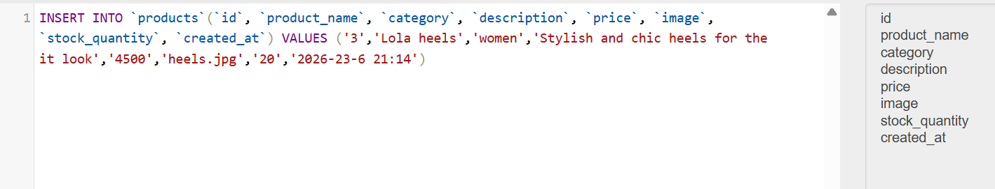


Fig 3: Shows the successful execution by an admin of adding a new product using form.It is inserted using queries in phpmyadmin and it reflects successfully on the page.

READ(Viewing product)
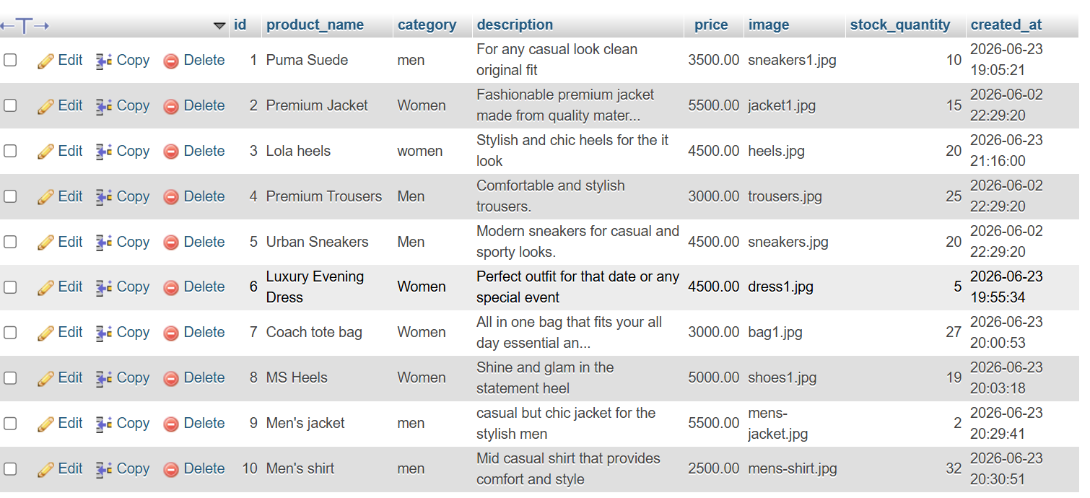


Fig4: Shows that products from the database are retrieved from the database and successfully displayed on the products page on with all categories included.

UPDATE(Edit product)
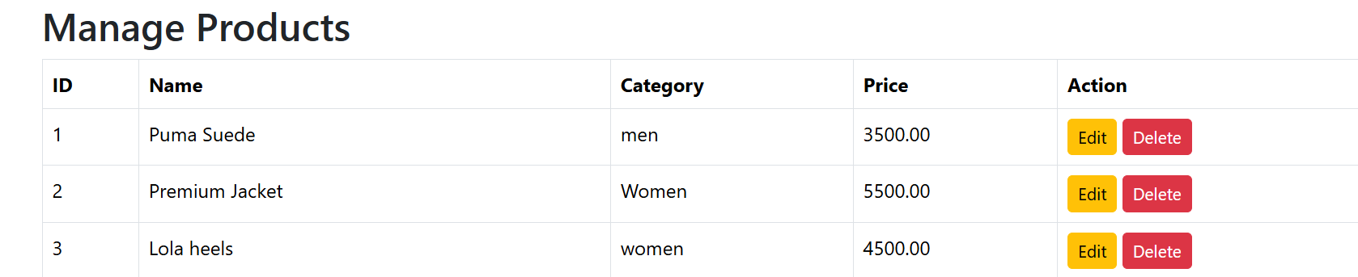
This shows that the admin has a buton dedicated t editing a product.
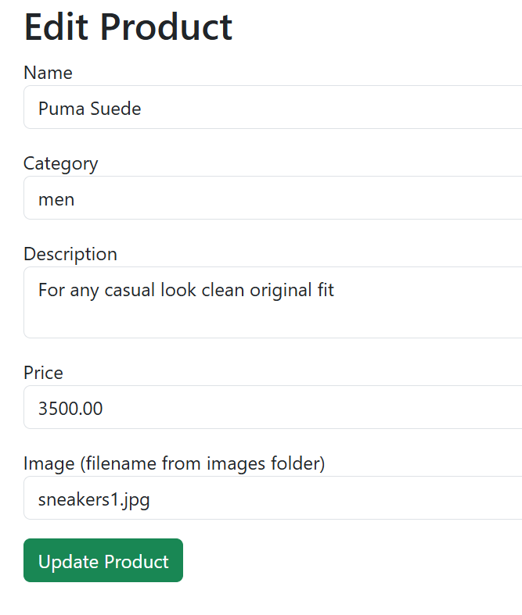.
This shows the form where the admin can edit specifics about the product.

Shows the edited price of the product from 3500 to 3000.This shows the admin has the flexibility to change product details at preference.

The SQL UPDATE statement is used to modify the existing records in the database.This ensures that product information remains accurate and upto date.
DELETE(Deleting product)

Shows the admin is able to delete a product with a button indication for it.


Shows the product was deleted successfully from the page.
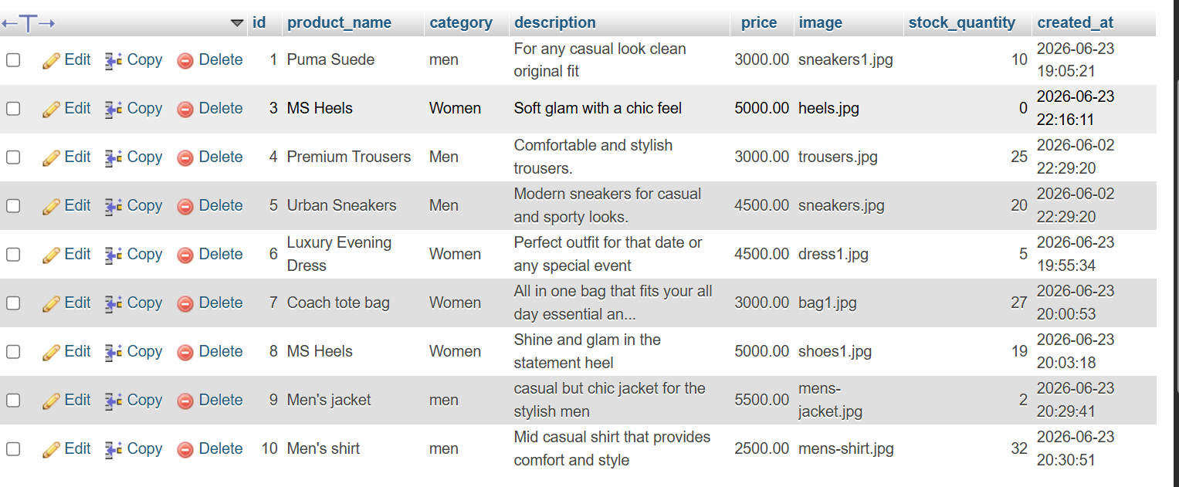
Shows the successful deletion of product 2 from the database.

Week 7 :User authentication and session management
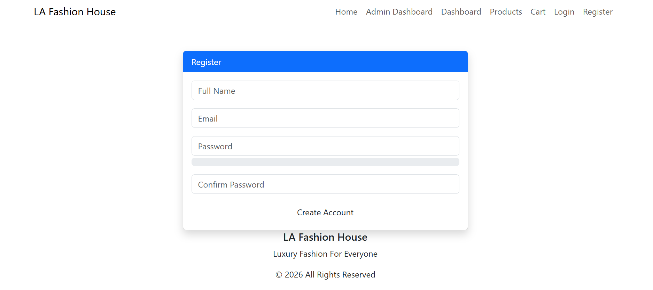
Fig1: The figure shows the user registration form where new users sign up to the system upon filling required fields the passwords are hashed before storing in the database.
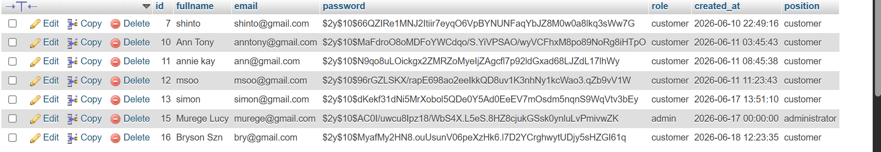
Fig2: This shows the users table in the database after registration.It shows the hashed passwords and user roles according to how they registered to the system.
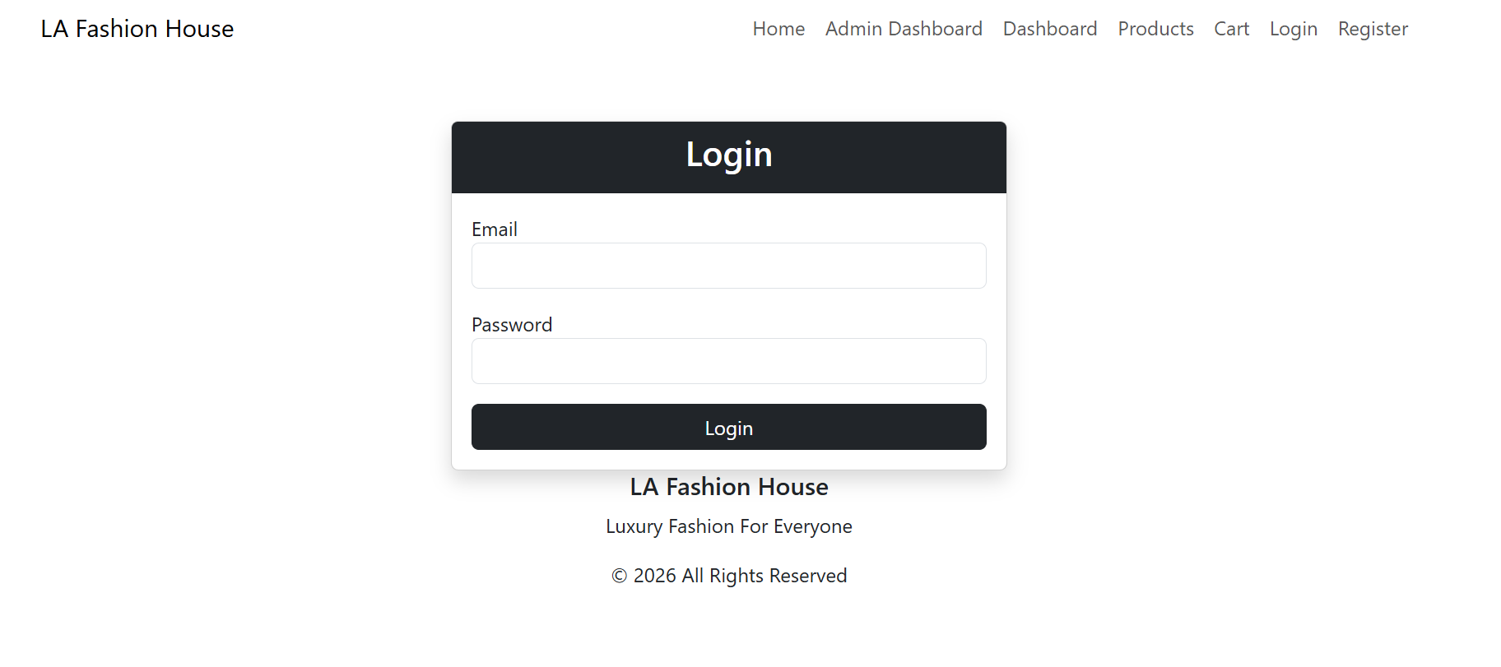

Fig3:The figure shows the log in page where registered users log in to access the system.

Fig4:This shows the home page after a user successfully logs in.
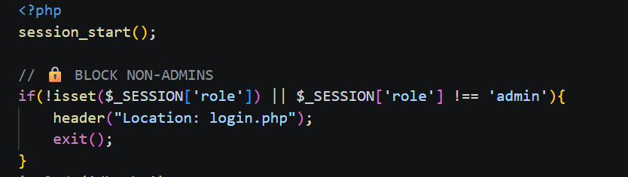
Fig5:The figure shows the admin_dashboard.php code that shows only the admin can access the page upon log in.
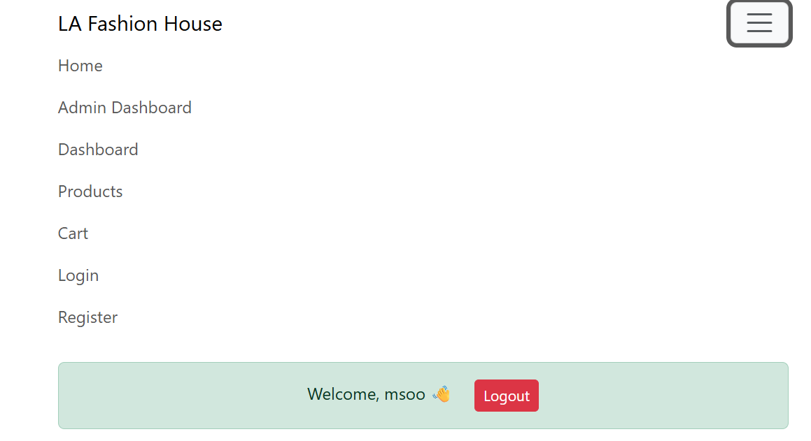

Fig6:This shows when a user logs in as a customer and tries to access the admin dashboard they are redirected to the log in page(denial of entry) .


Fig7:The figure shows the log out functionality the session is destroyed and the user is redirected to the log in page.
Week 8:Responsive web design and mobile first development

Fig 1:This shows that the system is functional before any altercations for the mobile responsiveness.
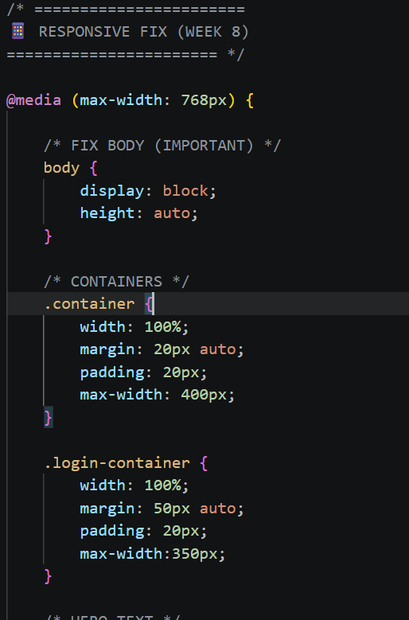n
Fig2:This shows tha modification of my style.css code to include the improving of the responsiveness and appearance.
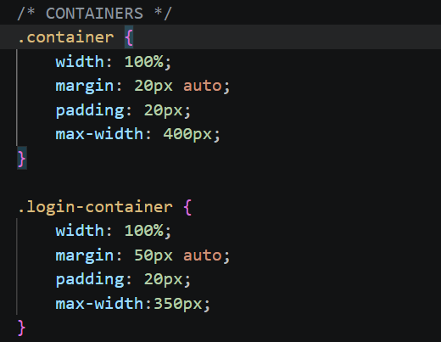
Fig3: This shows the implementation of CSS media queries to support different screen sizes.

Fig4:This shows the testing of the mobile responsiveness on a mobile device .The testing showed fulll functionality of the system on a mobile phone.

Fig 5&6:This shows the view of the page on a tablet screen dimension.It shows that a user can browse trough easily with the page still interactive.

Fig7:Shows the appearance of the website on a desktop.I tested its responsiveness in all the three mentioned dimensions and it proved to function.
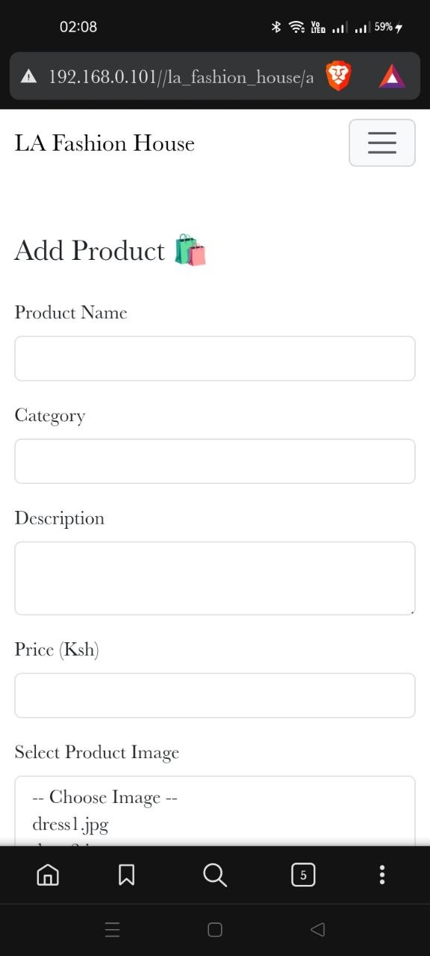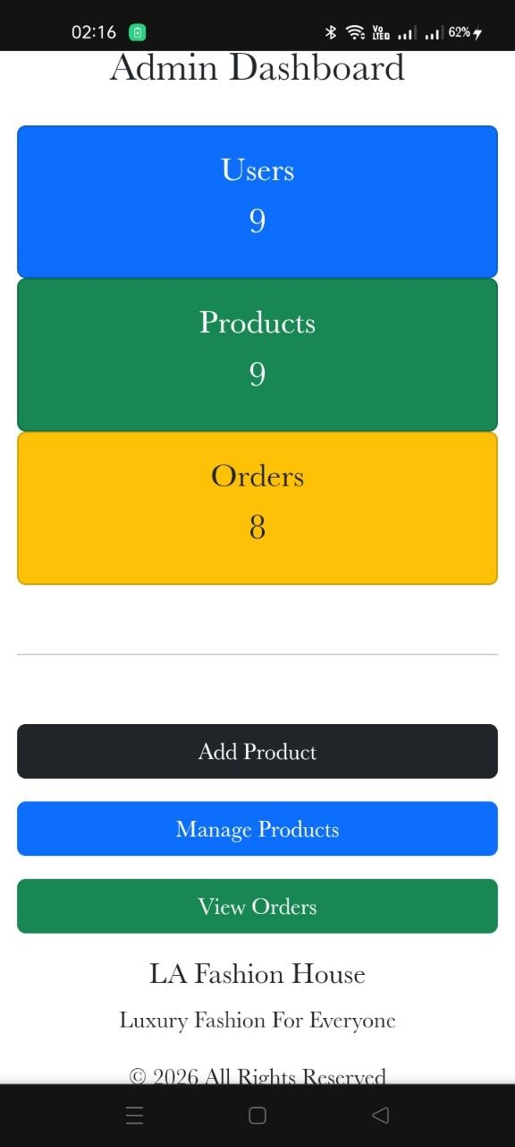
Fig8:This image shows that the admin functionality is responsive on any device.The admin can easily access logs to add,manage and view orders on any device.

Fig9:This shows the responsiveness of the products page on differenet dimension where on a mobile it is one device at a time while in a tablet its four at a go.

